**Improving Apriori Algorithm**

**1. Introduction**The Apriori algorithm is a classic algorithm in data mining used for frequent itemset mining and association rule learning. Despite its wide application, Apriori has significant performance bottlenecks, especially with large databases due to its candidate generation and multiple database scans.  
  
Improving the Apriori algorithm focuses on:

* Reducing computation and memory usage.
* Handling large and complex datasets.
* Enhancing scalability and real-time performance.

**2. Limitations of Standard Apriori Algorithm**

| **Limitation** | **Explanation** |
| --- | --- |
| **Excessive Database Scans** | The algorithm performs a full scan of the database for each iteration (i.e., each itemset size), leading to high I/O costs and inefficiency. |
| **Explosive Candidate Generation** | The number of candidate itemsets grows exponentially with the number of items, resulting in combinatorial explosion and increased memory usage. |
| **Costly Support Counting** | Every candidate itemset must be checked against all transactions to compute support, making the process computationally expensive. |
| **Poor Performance on Sparse Data** | In datasets where meaningful patterns are rare, Apriori generates many infrequent or irrelevant itemsets, leading to low efficiency and high processing time. |

**3. Improvement Techniques  
3.1. Reducing Scanning of the Database**

**🔸Hash-Based Technique**

* Use a hash table to count itemset frequencies during a single scan.
* Reduces the number of candidate itemsets in early iterations.

**🔸 Transaction Reduction**

* Remove transactions that do **not contain** any frequent itemsets.
* Reduces unnecessary computation in subsequent passes.

🔸 **Partitioning**

* Divide the database into non-overlapping partitions.
* Locally mine frequent itemsets, and combine global results.

**3.2. Reducing Candidate Generation**

**🔸 FP-Growth (Frequent Pattern Growth)**

* Constructs a compact prefix-tree (FP-Tree).
* Avoids candidate generation by using recursive pattern growth.

**🔸 ECLAT (Equivalence Class Transformation)**

* Uses **vertical data format** (item → list of transaction IDs).
* Performs support counting by **intersecting TID lists**.

**3.3. Efficient Data Structures**

**🔸 Trie / Hash Trees**

* Store candidate itemsets in a **tree format**.
* Enable fast insertion and lookup for counting.

**🔸 Bitmaps**

* Represent presence/absence of items using **bit vectors**.
* Support counting becomes a **bitwise AND operation**.

**3.4. Sampling Techniques**

* Use a **random sample** of the dataset to mine approximate frequent itemsets.
* Validate final itemsets against the full dataset to confirm accuracy.

**3.5. Parallel and Distributed Computing**

**🔸 MapReduce-Based Apriori**

* Implement Apriori using **Hadoop** or **Apache Spark**.
* Enables **distributed computation** across nodes.

**3.6. Constraint-Based Mining**

* Apply **user-defined constraints** such as:
  + Length of itemsets
  + Specific items must/must not be included
  + Aggregated value conditions (e.g., sum > threshold)

This reduces the search space and speeds up the mining process.

**3.7. Hybrid Approaches**

* Combine Apriori with **FP-Growth**, **sampling**, or **vertical formats**.
* Example: Use Apriori for small k-values, then switch to FP-Growth for higher orders.

**3.8. Database Projection**

* Project database into **conditional databases** based on prefix patterns.
* Reduces the size of the working database in each iteration.

**5. Conclusion**

The Apriori algorithm, while foundational, has known limitations that can significantly hinder performance on large datasets. Multiple improvements and optimizations—ranging from data structure changes to algorithmic overhauls like FP-Growth—can enhance both efficiency and scalability.

Choosing the right improvement method depends on:

* Dataset size and density
* Required accuracy and speed
* Available computing resources

**FP-Growth**

**1. Introduction**

FP-Growth is a fast algorithm for discovering frequent itemsets in large datasets. Unlike Apriori, which repeatedly scans the database and generates numerous candidate sets, FP-Growth uses a compact data structure called the FP-Tree. This allows it to find patterns directly and more efficiently, making it well-suited for large-scale data mining tasks.

**2. FP-Growth Algorithm Steps**

1. **Data Compression (Building the FP-Tree):**  
   FP-Growth begins by compressing the dataset into a compact structure called the **Frequent Pattern Tree (FP-Tree)**. This tree captures itemsets and their frequencies **without generating candidate sets**, making it much more efficient than Apriori.
2. **Mining the Tree:**  
   The algorithm then **recursively explores the FP-Tree** to find frequent patterns. It does this by creating smaller **conditional FP-Trees** for each item, allowing it to focus on relevant parts of the dataset and avoid redundant computations.
3. **Generating Frequent Patterns:**  
   Once mining is complete, FP-Growth outputs all **frequent itemsets** that meet the minimum support threshold. From these itemsets, **association rules** can be derived to reveal meaningful relationships between items.

**Example:**

**Step 1: Input Transactions**Let’s take a sample dataset of transactions:

| **Transaction ID** | **Items** |
| --- | --- |
| **T1** | A, B |
| **T2** | B, C, D |
| **T3** | A, C, D, E |
| **T4** | A, D, E |
| **T5** | A, B, C |

Let’s set minimum support = 2.

**Step 2: Count Item Frequencies**Count how many times each item appears and set the priority:

* A: 4 (priority 1)
* B: 3 (priority 2)
* C: 3 (priority 3)
* D: 3 (priority 4)
* E: 2 (priority 5)

Remove infrequent items (**none here**, since all ≥ 2).

Now **sort items in each transaction** by its priority:

| **Transaction** | **Sorted Frequent Items** |
| --- | --- |
| T1 | A, B |
| T2 | B, C, D |
| T3 | A, C, D, E → A, C, D, E |
| T4 | A, D, E |
| T5 | A, B, C |

**Step 3: Build FP-Tree**

How It Works:

* Start with a null root.
* For each transaction, insert sorted items into the tree.
* Items with common prefixes share the same path.  
  **T1: A → B**Root → A(1) → B(1)  
  **T2: B → C → D**Root → B(1) → C(1) → D(1)  
  **T3: A → C → D → E**Root **→** A(1 → increment to 2) → C(1) → D(1) → E(1)  
  **T4: A → D → E**Root **→** A(1 → increment to 3) → D(1) → E(1) (New Path)  
  **T5: A → B → C**Root**→** A(3 → increment to 4) →B(1 → increment to 2) → C(1)

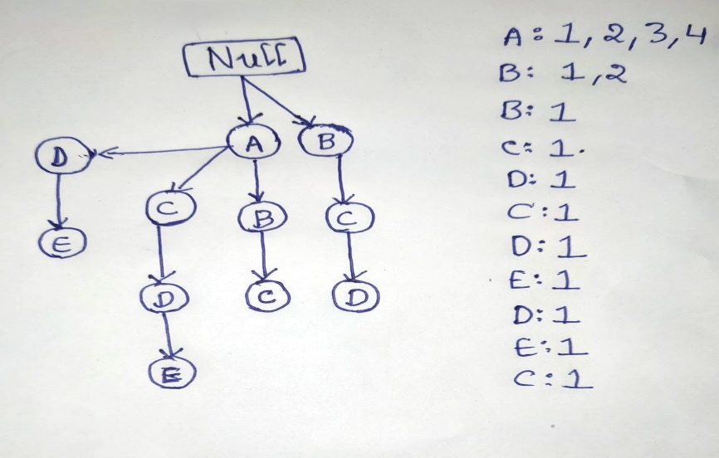

**Step4:**Let’s now summarize all the nodes and their frequency counts in the tree.  
**Node Frequencies (by traversal):**

| **Node** | **Frequency** | **Parent** | **Path Example** |
| --- | --- | --- | --- |
| **A** | **4** | **Root** | **A appears in T1, T3, T4, T5** |
| **B** | **2** | **A** | **A → B from T1 & T5** |
| **B** | **1** | **Root** | **Root → B from T2** |
| **C** | **1** | **B (under Root)** | **B → C from T2** |
| **C** | **1** | **A** | **A → C from T3** |
| **C** | **1** | **B (under A)** | **A → B → C from T5** |
| **D** | **1** | **C (under A)** | **A → C → D from T3** |
| **D** | **1** | **C (under B)** | **B → C → D from T2** |
| **D** | **1** | **A** | **A → D from T4** |
| **E** | **1** | **D (under A)** | **A → D → E from T4** |
| **E** | **1** | **D (under C)** | **A → C → D → E from T3** |

From above frequency table set the priority for Nodes/ Items.

| **Item** | **Frequency** | **Priority** |
| --- | --- | --- |
| A | 4 | 1 |
| B | 3 | 2 |
| C | 3 | 3 |
| D | 3 | 4 |
| E | 2 | 5 |

**🔷 Step 5: Mining the FP-Tree (Generating Conditional FP-Trees)**

**🎯 Purpose:**

To **recursively extract frequent itemsets** by exploring **conditional patterns** for each item starting from the **least frequent item** upward.

**✅ How It Works:**

1. **Start from the lowest priority item (E)**.
2. **Find all paths that lead to E** (prefix paths).
3. **Construct the conditional pattern base** (prefix paths that lead to the item).
4. **Build the conditional FP-Tree** using only items in those prefix paths that meet the support threshold.
5. **Repeat recursively** for all items in the conditional tree.

**🧪 Example Using Your Dataset (Min Support = 2):**

**Mining for E (lowest priority):**

**Prefix paths for E:**

* A → C → D → E (T3)
* A → D → E (T4)

**Remove E from paths:**

* Path 1: A, C, D → count = 1
* Path 2: A, D → count = 1

**Item counts in conditional pattern base:**

* A: 2
* D: 2
* C: 1 (remove, below min support)

**Conditional FP-Tree for E:**

* A(2) → D(2)

**Frequent itemsets involving E:**

* {E}
* {D, E}
* {A, E}
* {A, D, E} ✅

**Repeat This for:**

* D
* C
* B
* A
* Each time, you're mining **conditional patterns** for each item.

**🔷 Step 6: Generating All Frequent Itemsets**

**Purpose:**

After all conditional FP-Trees have been mined, collect **all frequent itemsets** discovered in the process.

**What This Includes:**

For each item, combine:

* The item itself
* All combinations from its conditional FP-Tree

| **Frequent Itemset** | **Support** |
| --- | --- |
| {E} | 2 |
| {A, E} | 2 |
| {D, E} | 2 |
| {A, D, E} | 2 |
| {D} | 3 |
| {A, D} | 2 |
| {C, D} | 2 |
| {A, C, D} | 2 |
| {B} | 3 |
| {A, B} | 2 |
| {A, B, C} | 1 ❌ (below threshold — not included) |